Memorandum
Harris CountyJuvenile probation department
1200 Congress Avenue Houston, TX 77002

Student(s) name: Douglas | Report title/topic: Monitors
Criteria | Comments |  | Points
Writing: Does the writer persuade the reader to fund or implement his/her idea? Is the report well written on the sentence level in terms of grammar, style, and expression? See Track Changes.  (10 points)  Look carefully at my comments and your own writing. There are places that almost appear to be random words. Some sentences are repeated and there are many words or sentences to do not make sense. I do not know if this was because of careless copying and pasting or just inattentive editing, but the report was very hard to understand. |  | 4
Genre conventions: Front matter: Does the paper meet the conventions of the genre?
- Front matter/first page/format  (2 points)  - Letter format if external  - Memo format if internal  - Conventions followed |  |  | 1
Research: Is the research thorough and compelling?
- Body (10 points)  - Introduction  - Research  - Discussion  - Conclusion | You do have some research here but overall you did not make your research process evident to the reader. |  | 4
Genre conventions: Back matter: Does the paper meet the conventions of the genre?
- Back matter (1 point)  - Works cited  - Appendices |  |  | 1
Visual conventions: Are the visual elements purposeful, truthful, clear, and interesting?
- Visuals: (2 points)  - Are the visuals purposeful, truthful, clear, and interesting  - Are the visuals labeled and placed in appropriate locations? |  |  | 2
Total: 12/25 points
Grade Range
A = 25-22.5 points B = 22.49-20 points C = 19.99-17.5 points D = 17.49-15 points F = below 14.99 points

Date: November 29, 2018
To: Finance Committee/Public
From: LaQuana Douglas, Juvenile Supervision Officer
Subject: Electronic Monitoring Device
The purpose for this proposal is to provide information as to Harris County regarding electronic monitoring devices for juvenile offenders.



Introduction
Throughout my duration with the Harris County Juvenile Probation Department, I have witnessed many juveniles go on their home visits for 24 hours and never return back to the court to complete their time. At one of the Harris County facilities, the home visits are one of the perks of completing the program; however, when a juvenile fails to come back to the facility the County loses money trying to locate the juvenile. It also causes the other juveniles to not be able to go on their own home visits. I am proposing that we provide juvenile offenders an electronic monitoring device with GPS tracking to assure that the juvenile offenders do return to facilities when they are temporarily released. Also, the electronic monitoring device will help law enforcement locate the juvenile.
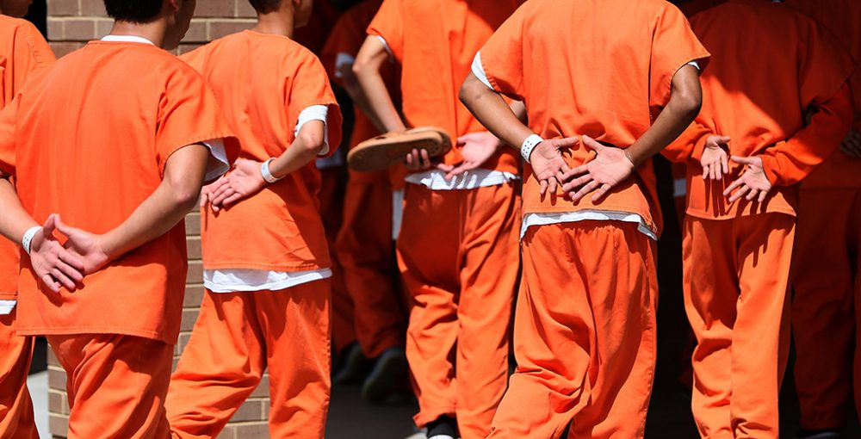

Research
The writing in this paragraph does not make sense.

Adolescents who are and have been in the court frameworks are starting to count. The quantities of these adolescents are rising, and there are prime key factors that prompt this proceeding with issue. In the present paper the Probation Officer might be a key factor to the jobs that the Probation Officer plays in their life. It is realized that the Probation Officers have with enhancing their standard for dependability. has a merited notoriety for quality client benefit. Notwithstanding, looked with changes in dissemination frameworks, financial effects to transportation and coordination, and impediments that avoid taking full preferred standpoint of enhancements in innovation, Harris County Juvenile Probation Department is the biggest adolescent detainment focus in Texas. Adolescents that are and have been in the court frameworks are starting to list. The quantities of these adolescents are rising, and there are prime key factors that prompt this proceeding with issue. The principles that have been in a place frequently sent a few children to the detainment focus if they missed seven days of school, while other people who ought to have been sent home. With respect to kids who were bring down hazard or don't present issues to the network, there are different options other than detainment, for example, network supervision by a post-trial agent and home supervision. A portion of the projects set for the children are end of the week trips home and outpatient treatment. The adolescent detainment focus is fit for being home to more than 350 adolescents.

dISCUSSION
The electronic monitoring device incorporate the supervision of guilty parties through any electronic gadget that tracks the whereabouts of wrongdoers either irregularly or persistently. After being alluded to an electronic checking program, wrongdoers must consent to pay the required expense set by the courts. Guilty parties who are put on an electronic monitor are regularly managed by probation officers. These officers oversee what guaranteeing consistence with the court orders, exploring infringement, detailing back to the court, and guaranteeing gear fit and utilization. In contrast to different officers of the court that expect some dimension of rehabilitative capacity, these officers are accused of guilty party the board and control rather than consideration. In contrast to different options, were intended to be utilized related to other network-based projects, for example, house capture, curfews, network benefit, and so forth. Guilty juvenile offenders might be put in electronic monitoring either pretrial or as an immediate sentence for probation through a network or redresses based program. This would be a place to start a new paragraph. Electronic checking has been utilized with an assortment of guilty parties including sex wrongdoers, rough guilty parties, aggressive behavior at home wrongdoers, pack individuals, and medication guilty parties. While every one of these projects contrasts by the motivation behind their organization, the supervision obligation continues as before. The guilty parties get arbitrary phone calls for the duration of the day when they should be home.
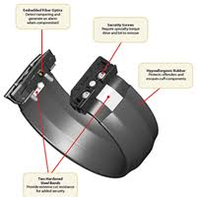

cONCLUSION
In the first place, electronic observing is a less expensive option in contrast to customary imprisonment. According to the Texas Juvenile Justice Department, it costs $437.11 a day to detain a juvenile. Further gauges of the extended utilization of GPS innovation propose a yearly decrease in wrongdoing would establish $481.1 billion in cost reserve funds. Further, by lessening the length of jail sentences from 85 to 50 percent of time served, the cost– advantage proportion to nationals would be a gain of $12.70 for each dollar consumed on GPS innovation. Concentrates on states of mind of undergrads toward electronic observing show that while white understudies see electronic checking as an adequate impediment to wrongdoing, despite everything they trust it is excessively permissive. The most convincing contention for keeping up EM in the network is the decrease in recidivism. Electronic monitoring programs give a chance to keep up open wellbeing while sufficiently rebuffing and overseeing guilty parties in the network. GPS-directed guilty parties are more averse to slip off, and when contrasted with a coordinated controlled gathering of detainees less inclined to recidivate. Further, investigate shows that early discovery of infringement on electronic monitoring gadgets has brought about an abatement in recidivism by 94.7 percent contrasted with an imprisoned populace.
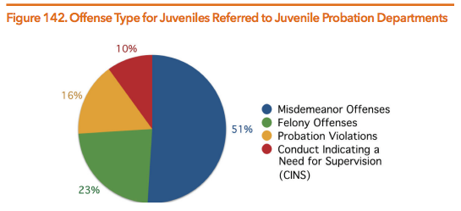

I look forward to working more with Harris County Juvenile Probation Department to make sure we are providing safety for our juveniles as well as our community.
If you have questions on this proposal, feel free to contact me at your convenience by email at laquaana.douglas@hcpjpd.com. We will be in touch with you next week to arrange a follow-up conversation on the proposal.
Thank you for your consideration,
LaQuana Douglas,
Juvenile Supervision Officer

Student(s) name: | Report title/topic:
Criteria | Comments |  | Points
Writing: Does the writer persuade the reader to fund or implement his/her idea? Is the report well written on the sentence level in terms of grammar, style, and expression? See Track Changes.
(10 points)

Does the writer persuade the reader to fund or implement his/her idea?
A below average report contains an idea only. For example, a below average report will proposal to an apartment manager or group that playground equipment be replaced. A below average report may also present the results of an online search of prices of playground equipment.

An average report will propose to a named apartment manager or group that the playground equipment be replaced. An average report will present results of an online search of prices of playground equipment. An average report will include images of the current equipment and make explicit why new equipment is needed. An average report will include a discussion of installation options as well as a timeline. An average report may bring in outside research on apartment amenities and renter satisfaction.

An above average report will propose to a named apartment manager or group that the playground equipment be replaced. An above average report anticipate and answers all of the questions the manager or management group has and makes a compelling case that the reader will see a benefit from the proposed changes. An above average report may include an interview with an apartment manager as well as survey to determine resident interest in or support of new playground equipment. An above average report avoids unsubstantiated leaps in logic. That is, the report does not claim without evidence that better playground will result in higher occupancy rates. A reader can take an above average report to his/her manager who can then confirm the claims in the report and – at least theoretically – proceed with the proposed changes.

Is the report well written on the sentence level in terms of grammar, style, and expression?
Each student has been given feedback throughout the semester on his or her writing on the sentence level. Does the report reflect an understanding of the feedback? Are the 10 suggestions followed or is the report filled with contractions and random capital letters and long paragraphs and meaningless adverbs? Do incomplete sentences or poor word choice diminish the credibility of the writer?

Genre Conventions: Does the paper meet the conventions of the genre?
- Front matter/first page/format  (2 points)  - Letter format if external  - Memo format if internal  - Conventions followed | If the audience for your report is internal (i.e., written to your supervisor), the report will be in memo format.  If the audience for your report is external (i.e., written to members of your HOA), the report will be in letter format.  If your report exceeds five pages in length (not including appendices), then you may want to write a formal report as seen on pages 490-511 of your book. A formal report has a title page, an abstract or executive summary (the example in the book has both), and a table of contents as the “front matter.” The five page designation is somewhat arbitrary. The example on pages 436-442 is seven pages but does not contain the traditional front matter one would find in a formal report.  Your report should follow conventions of technical/professional communication. It should be single spaced throughout and reflect preferred conventions of format and style in terms of font and paragraph length and clarity of expression.

Research: Is the research thorough and compelling?
- Body (10 points)  - Introduction  - Research  - Discussion  - Conclusion/Recommendation | Each report will develop differently, but all reports should have some combination of these or similar elements. Obviously, different topics may require different sections.  The report will have some kind of summary/introduction written after research is concluded and decisions reached. Too many students start with an introduction/summary before they have content to introduce or conclusions to summarize.  There also needs to be evidence of research. The report should not just contain the stated opinion of the writer over and over again. A strong report references relevant outside research from credible sources.  The discussion section reveals whether the writer understands the complexity of the situation by anticipating and answering questions that readers are likely to have. Surveys are explained, not just dropped into the report as though they speak for themselves.  The conclusions/recommendations make sense given the content of the rest of the report.

Genre conventions: Back matter: Does the paper meet the conventions of the genre?
- Back matter (1 point)  - Works cited  - Appendices | Your research will likely include outside sources. These sources need to be cited correctly using an identifiable citation method.  Your report should also have something in an appendix. An appendix appears at the end of the report and contains information that has been appended to (attached or added into) the report itself. The appended information is usually either too detailed to appear in the body of the report or is in some way additional to the report.  So, for example, if you have a long list of “Needed Materials” it may be easier for the reader if you state in the report “Please see Appendix A for a list of needed materials.” The reader can then flip to Appendix A to see a chart with all of the needed materials. Surveys should be discussed and analyzed in the report itself but the survey instrument is often moved out to an appendices, especially if it is long. You, as the writer, must decide if the chart or the survey instrument works better in the report or in the back of the report in the appendix. As always, think in terms of what strategy is easiest for the reader to process the information.  If you do not have something that needs to be moved into an appendix you can always include your resume at the end as evidence of your ability to take on the proposed task or a progress log showing the work you completed on the report. (An example progress log is below.)  A report can have many items in the appendices. Each item is listed separately (Appendix A, Appendix B, etc.) and should be referred to in the report itself.

Visual conventions: Are the visual elements purposeful, truthful, clear, and interesting?
- Visuals (2 points)  - Purposeful, truthful, clear, and interesting  - Labeled and placed in appropriate locations | Your report should contain a visual element. Visuals in technical communication are meaningful. They are not ornamental. They are easy to see and/or read and their content is relevant. Visuals do not mislead a reader. Visuals are labeled and place in close proximity to relevant written content.

